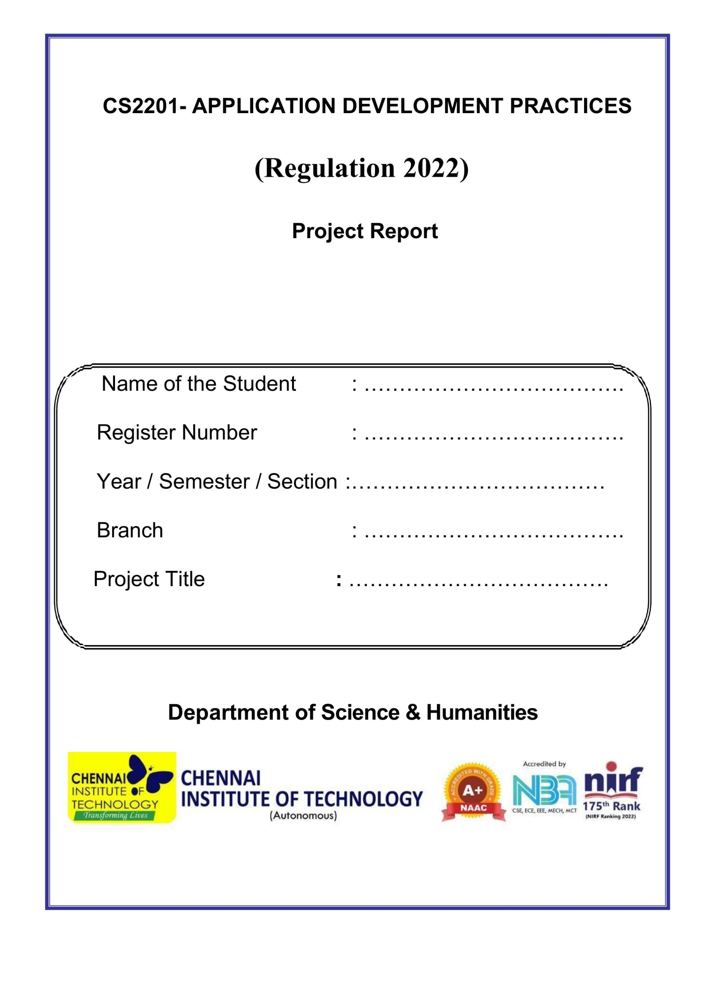

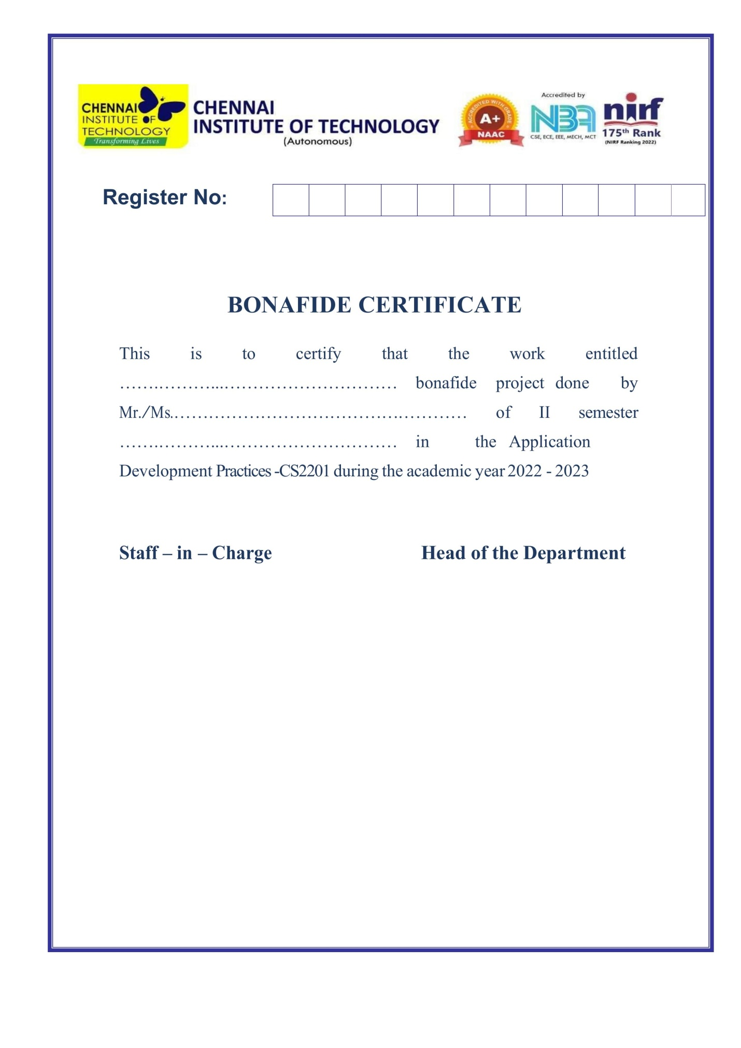

Project Name: Demo Website for Restaurant

Project Type: Web Application

Languages Used: HTML-5 , CSS-3, JavaScript

Description:

This is a website model for present the features of the restaurant and its key features. Html and css tags are used in the creation of webpage elements and designing is done with the help of css stylesheet. The behavior of the website is modified with the help of javascript.

Home Page:

The home page consist of the navigation bar which is linked to the subpages of the html document in order to avoid the cluttering of the document. The fonts used are Sans Serif fonts to enhance the looks of the webpage an icon is used as a logo for the webpage document as well as for branding purpose.

Slideshow:

The slide show is created with the help of html and javascript. The elements from the html document are imported to javscript and the effects are created with the help of basic functions with in the scripting language.

Food Page:

The food page is created with the help of floating elements and wraps the the text carefully not meddling with the image present above it. This is to give idea about the key features of the restaurant. And what the restaurant is actually famous for.

Menu Page:

The menu page consists of list items of the restaurant what the actually serve to the customers and they have provided the menu for the idea for the customers. The menu serves as a guidline when they actually want to order.

Price List:

The price list is actually a table where all the items are carefully placed and and give a rough estmate of each item they make and what they cost.

Order And Bill:

In case of ordering the customers can check out their total bill for the food items they select and can print the order receipt for future reference and other billings. Again the order placing concept is written in javascript where the itmes are placed as properties and summation is calculated.

About Us:

The about us is the general idea of the restaurant .Why should customers should choose their restaurant and so on it basically gives an overview about their franchise and other details.

Write to us:

It is actually a form where the customers can give their suggestions and grievances out to the company in case if they want to something else form their side to the restaurant